**Homework-1: Systems Setup and GitHub Skills**

Cheng An Hsieh (tothemoon)

**Part – I**

1. Anaconda Python 3.x

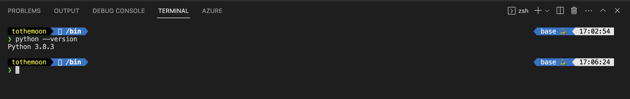

1. Jupyter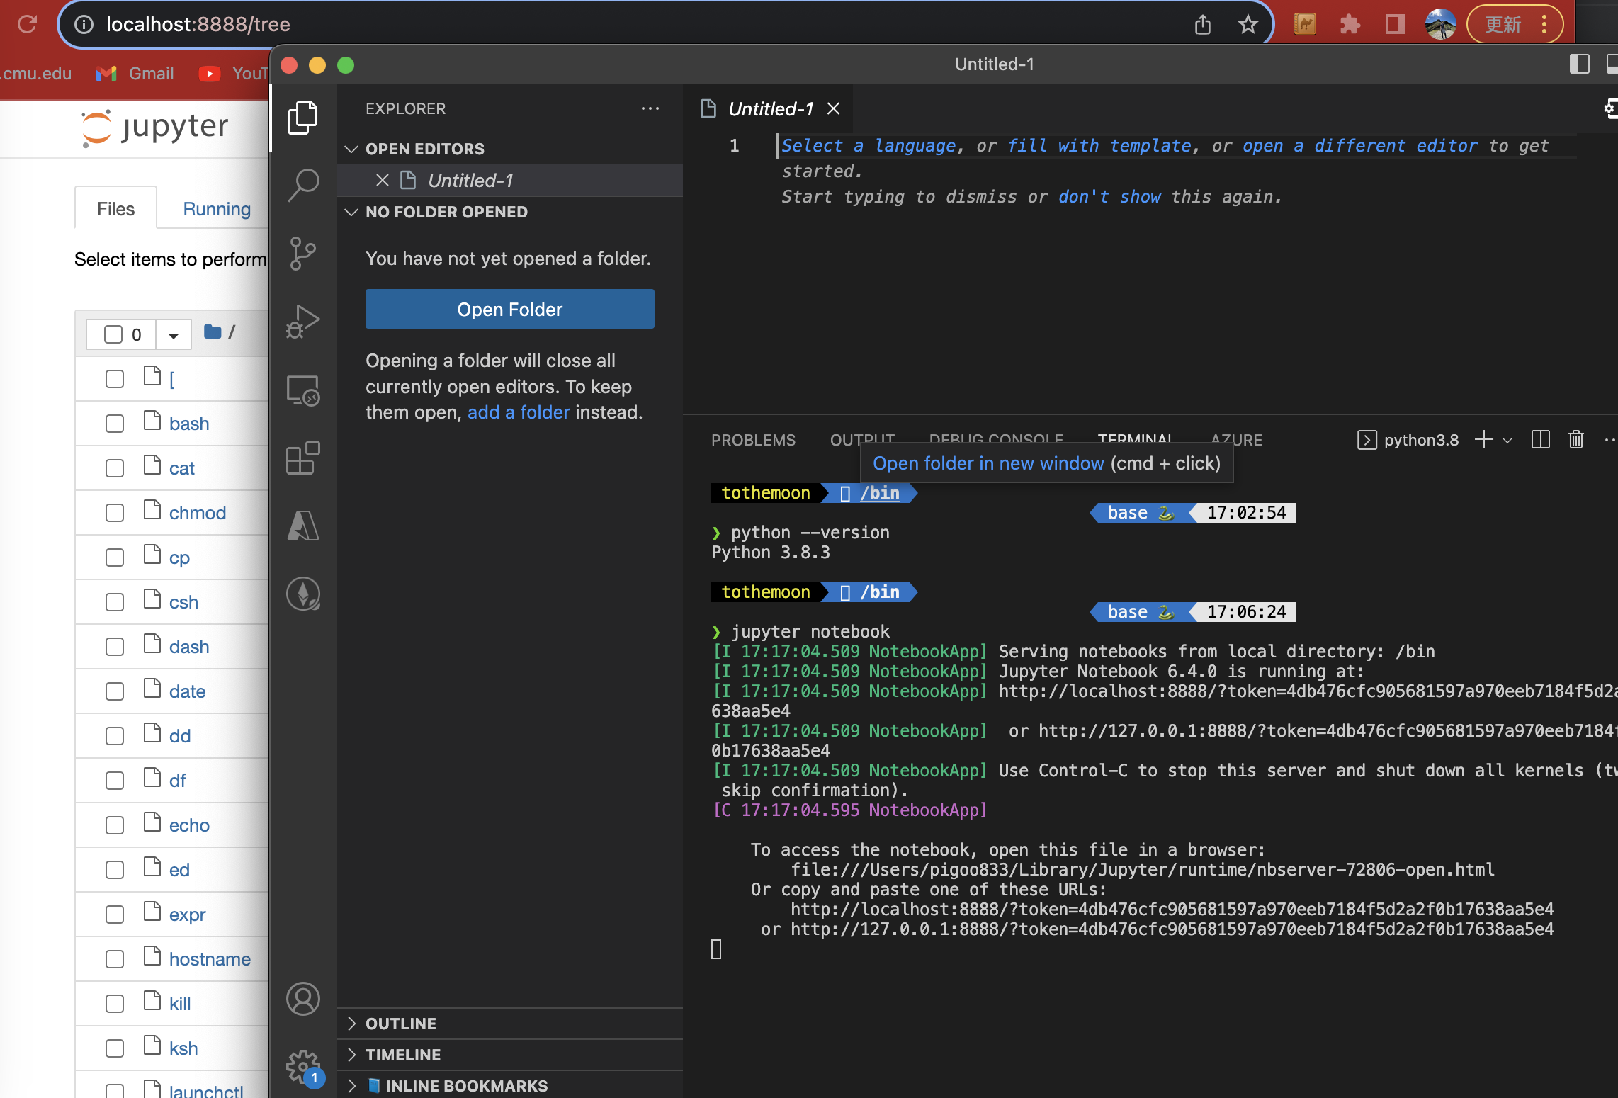
2. PostgreSQL DB

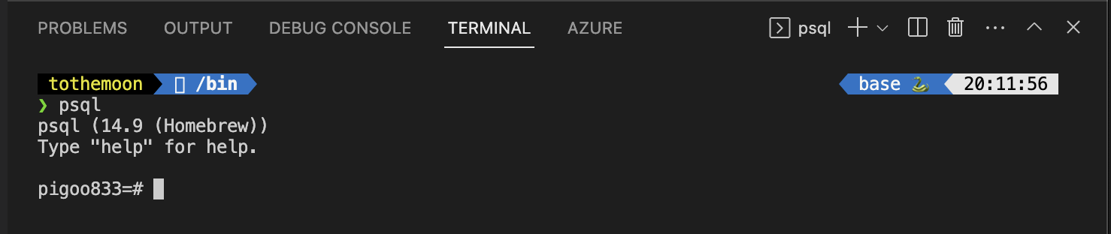

1. Pgadmin4  
   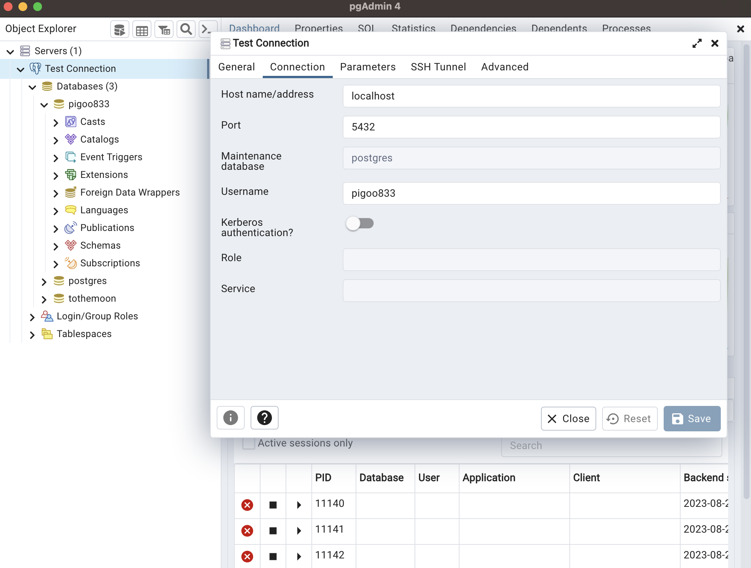
2. Apache Spark

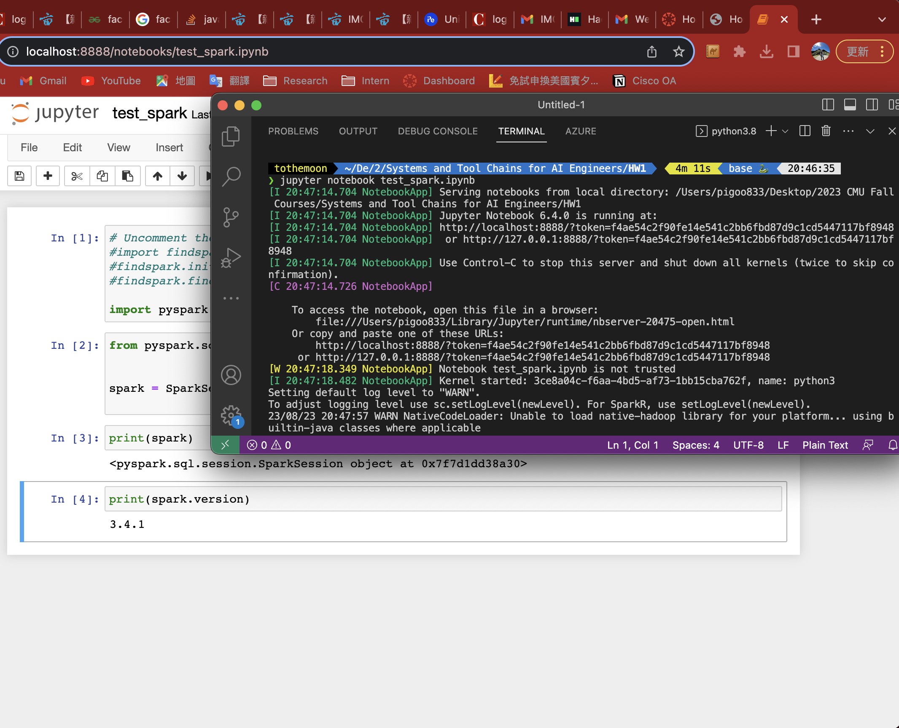

1. Tensorflow

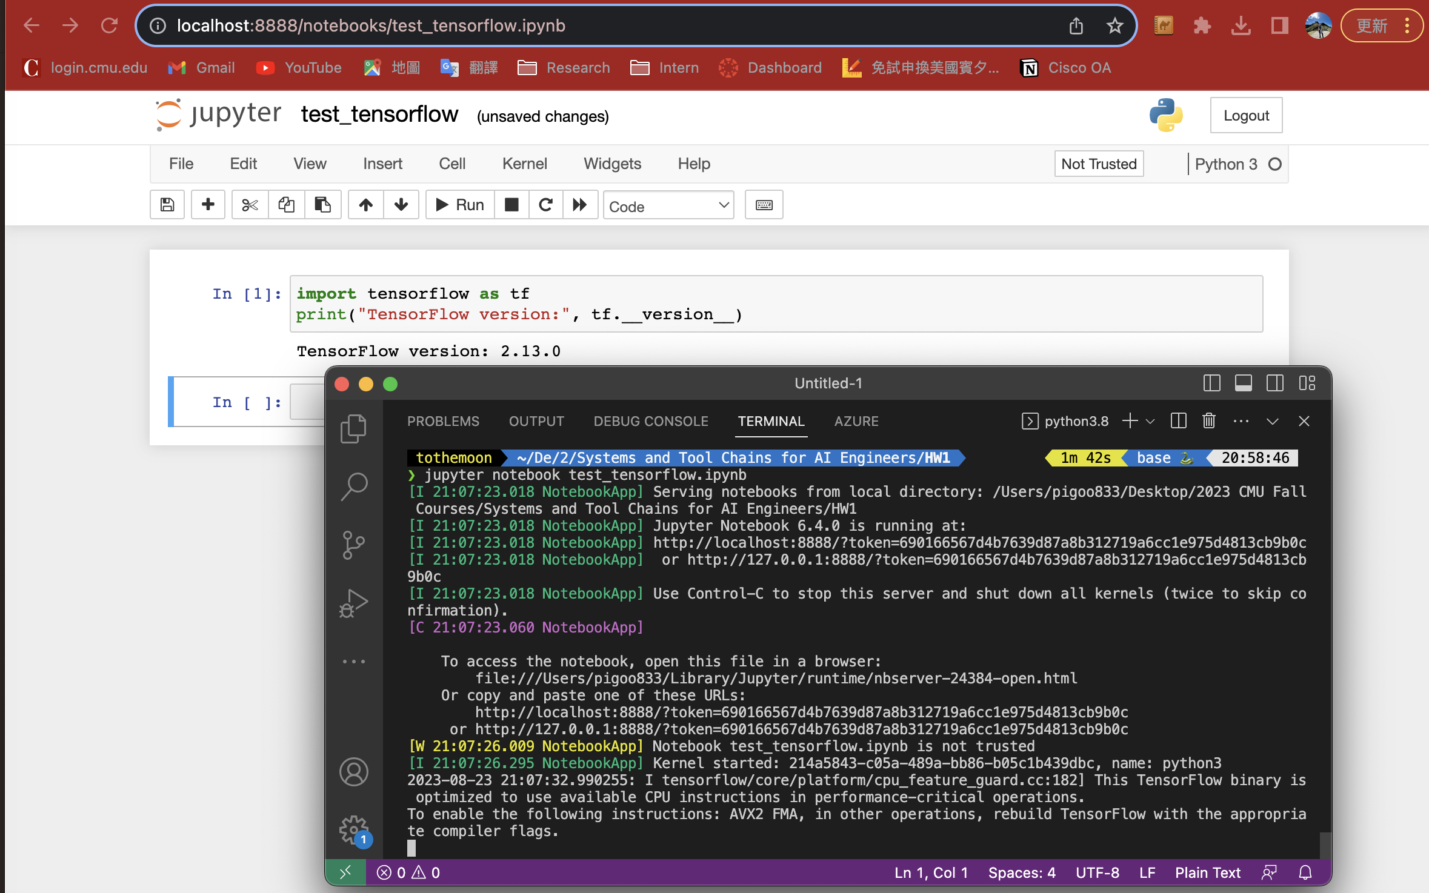

1. Pytorch

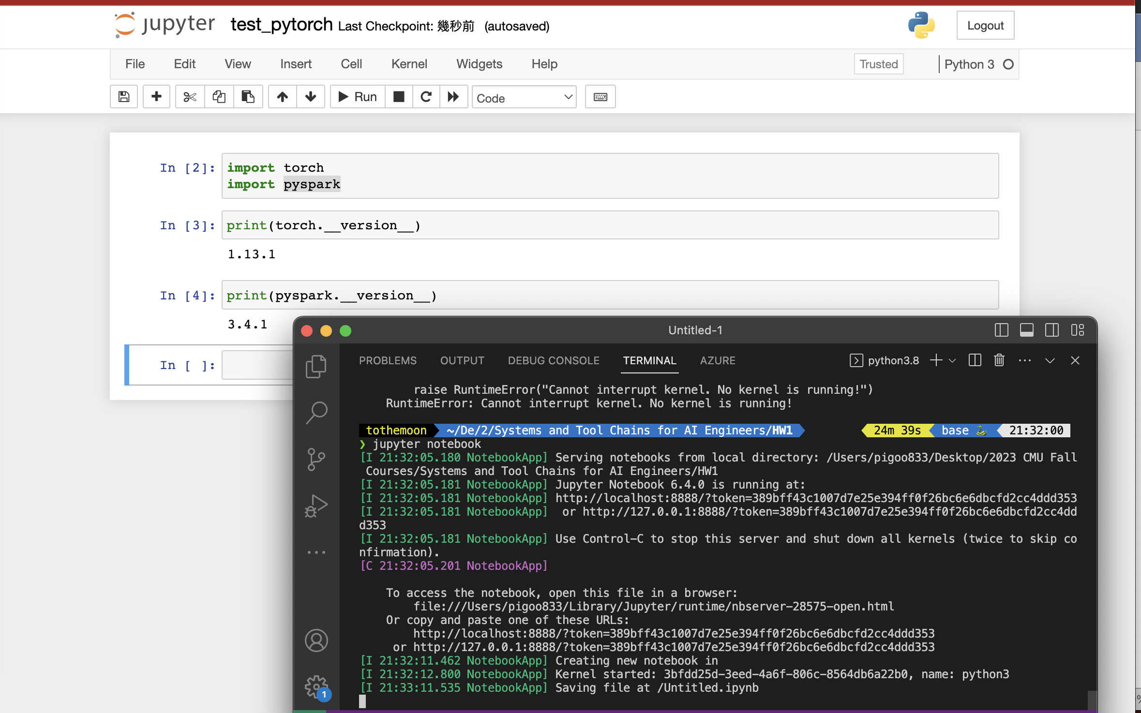

1. Docker



**Part – II**

1. **Complete Introduction to GitHub**
   * 1. **Create a branch**

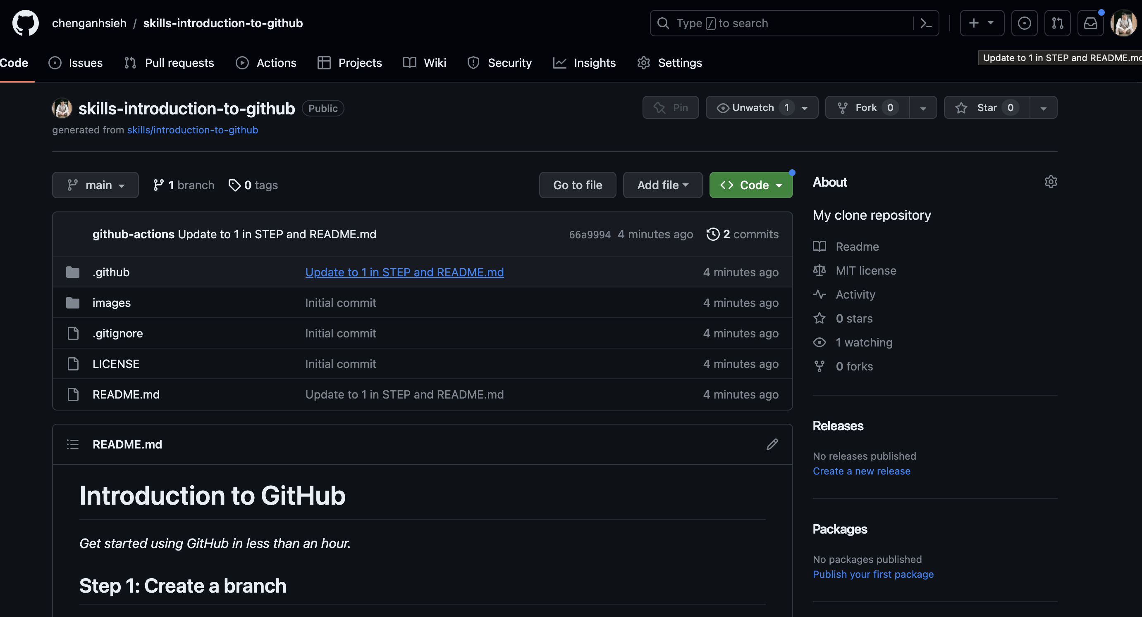

* + 1. **Commit a file**

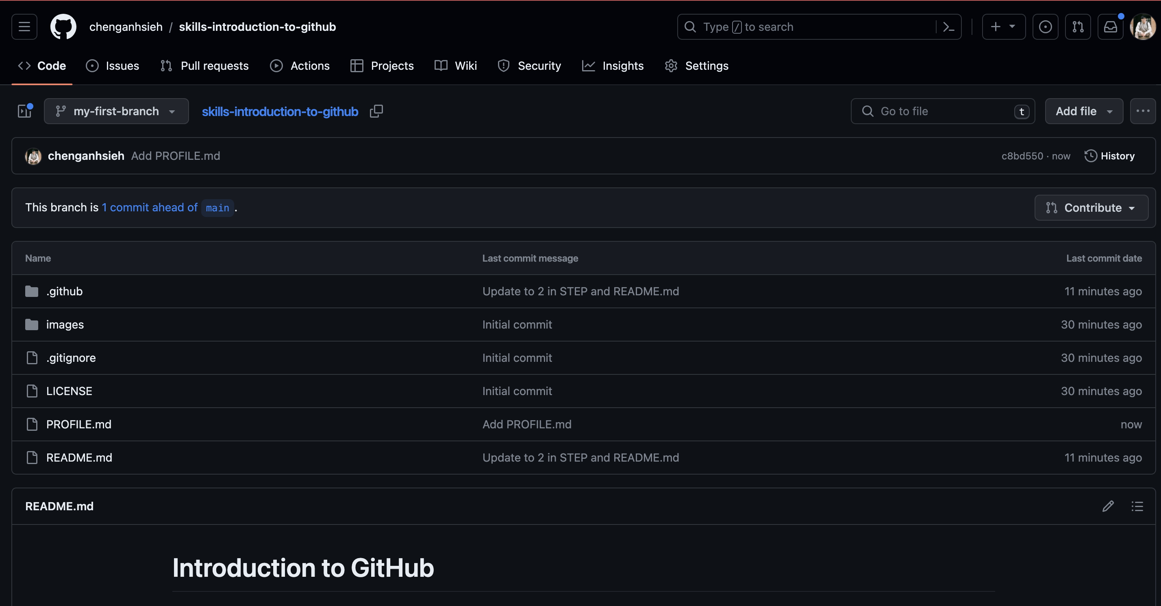

* + 1. **Open a pull request**

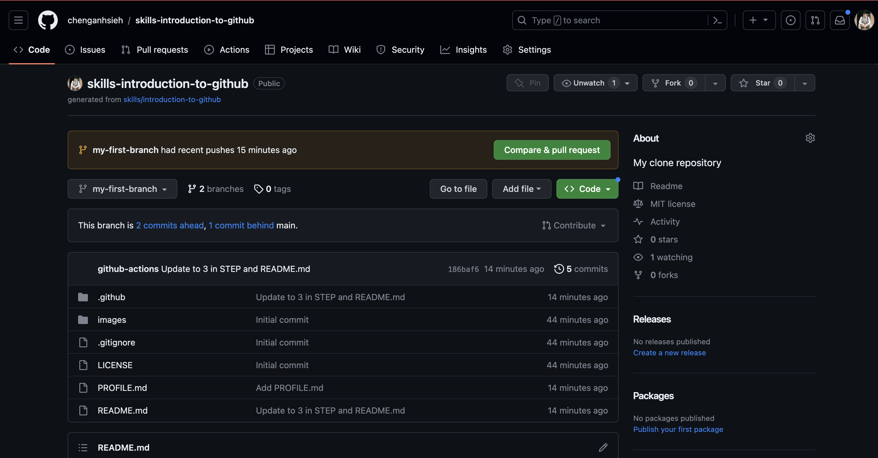

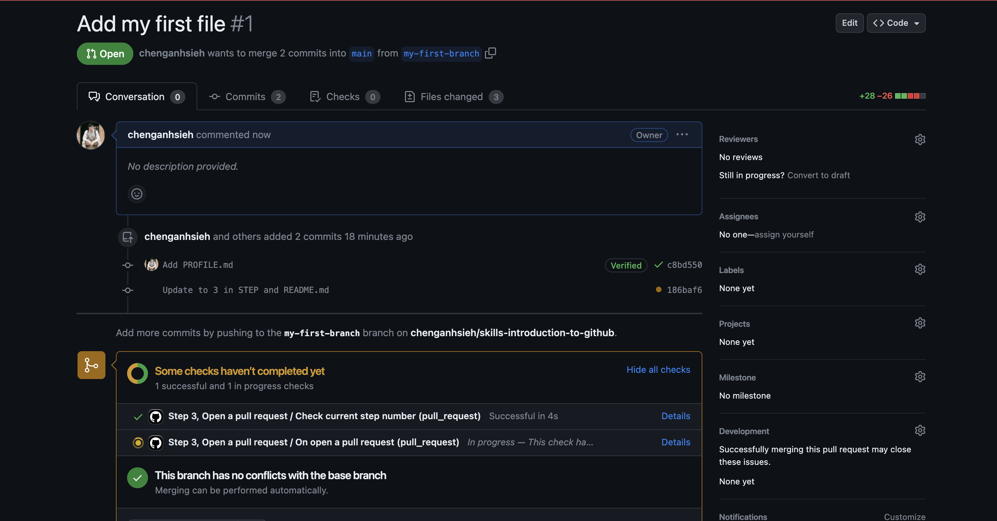

* + 1. **Merge pull request**

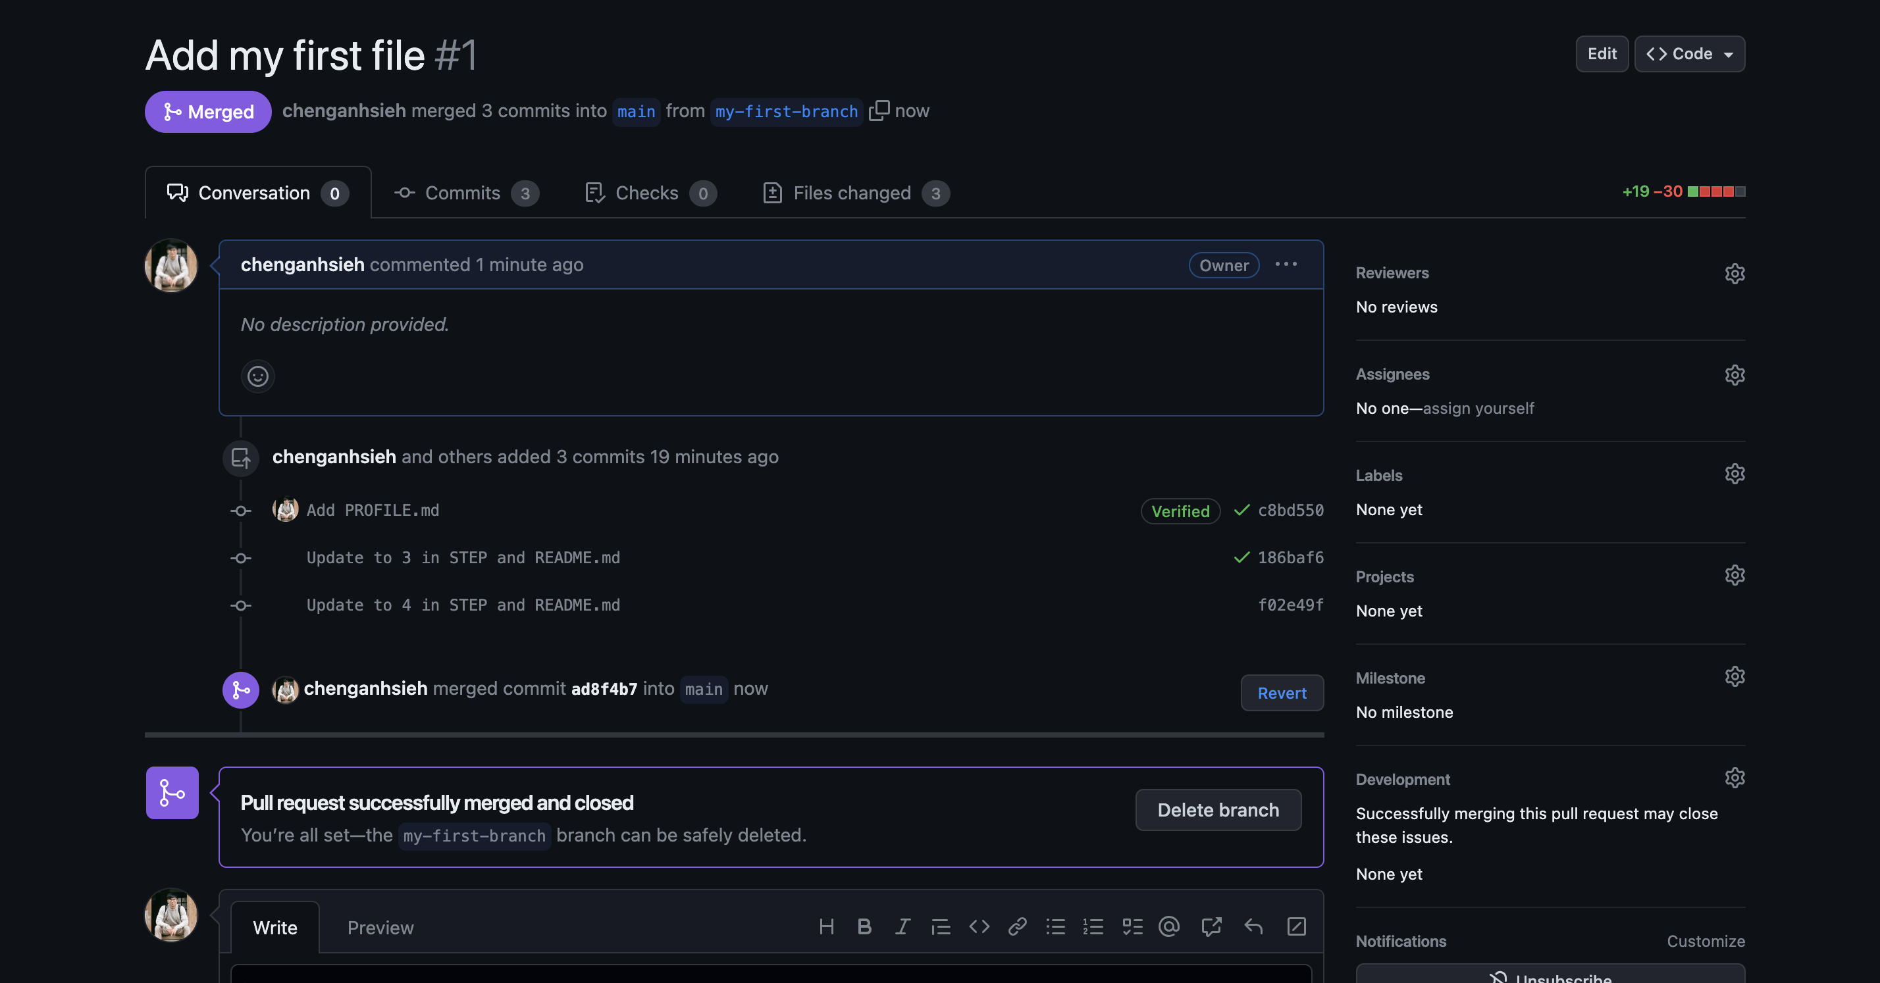

* + 1. **Finish**

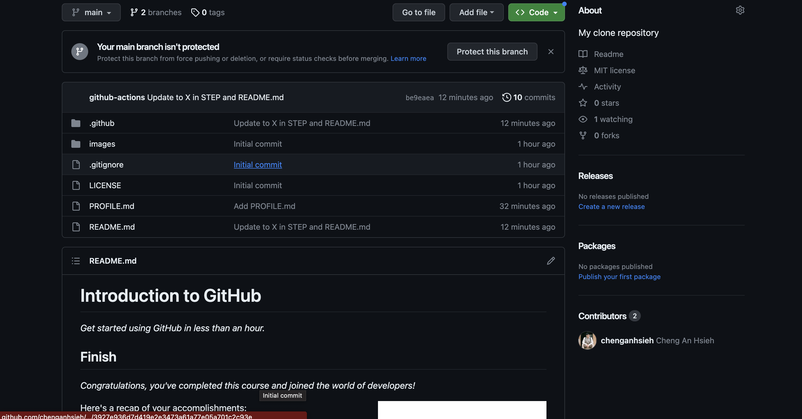

1. **Complete communicate-using-markdown**
   * 1. **Add headers**

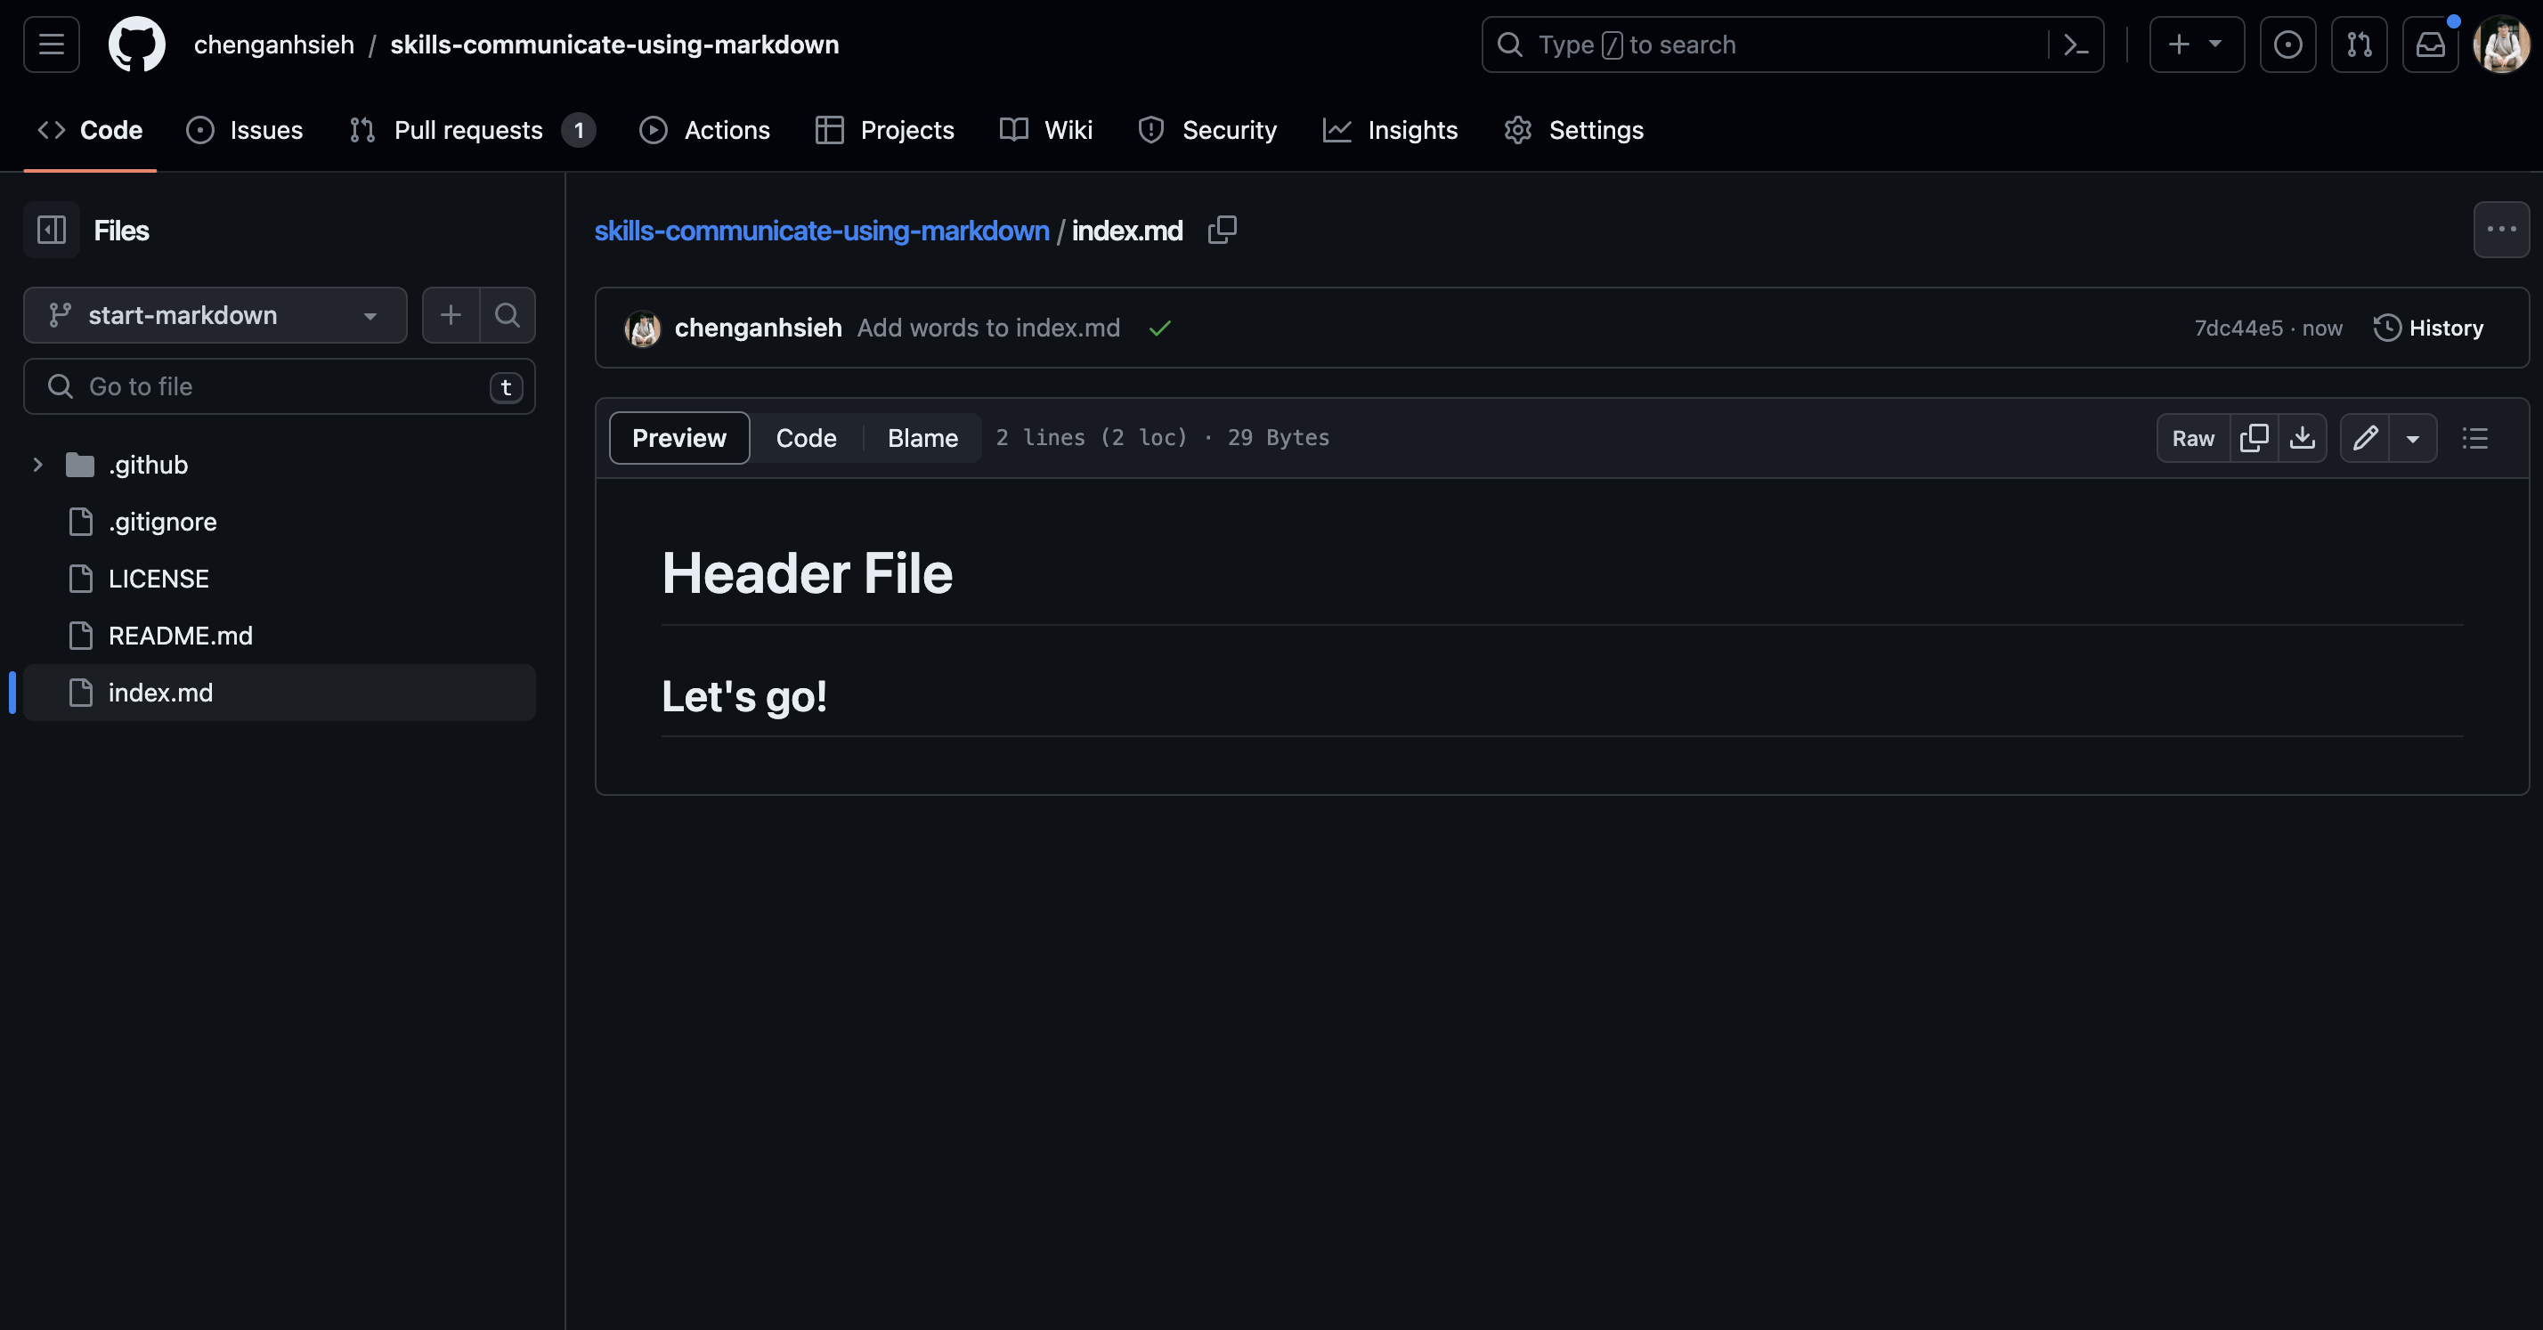

* + 1. **Add an image**

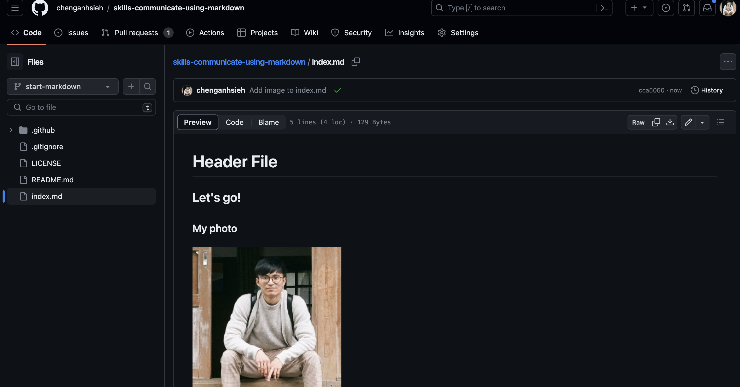

* + 1. **Add a code example**

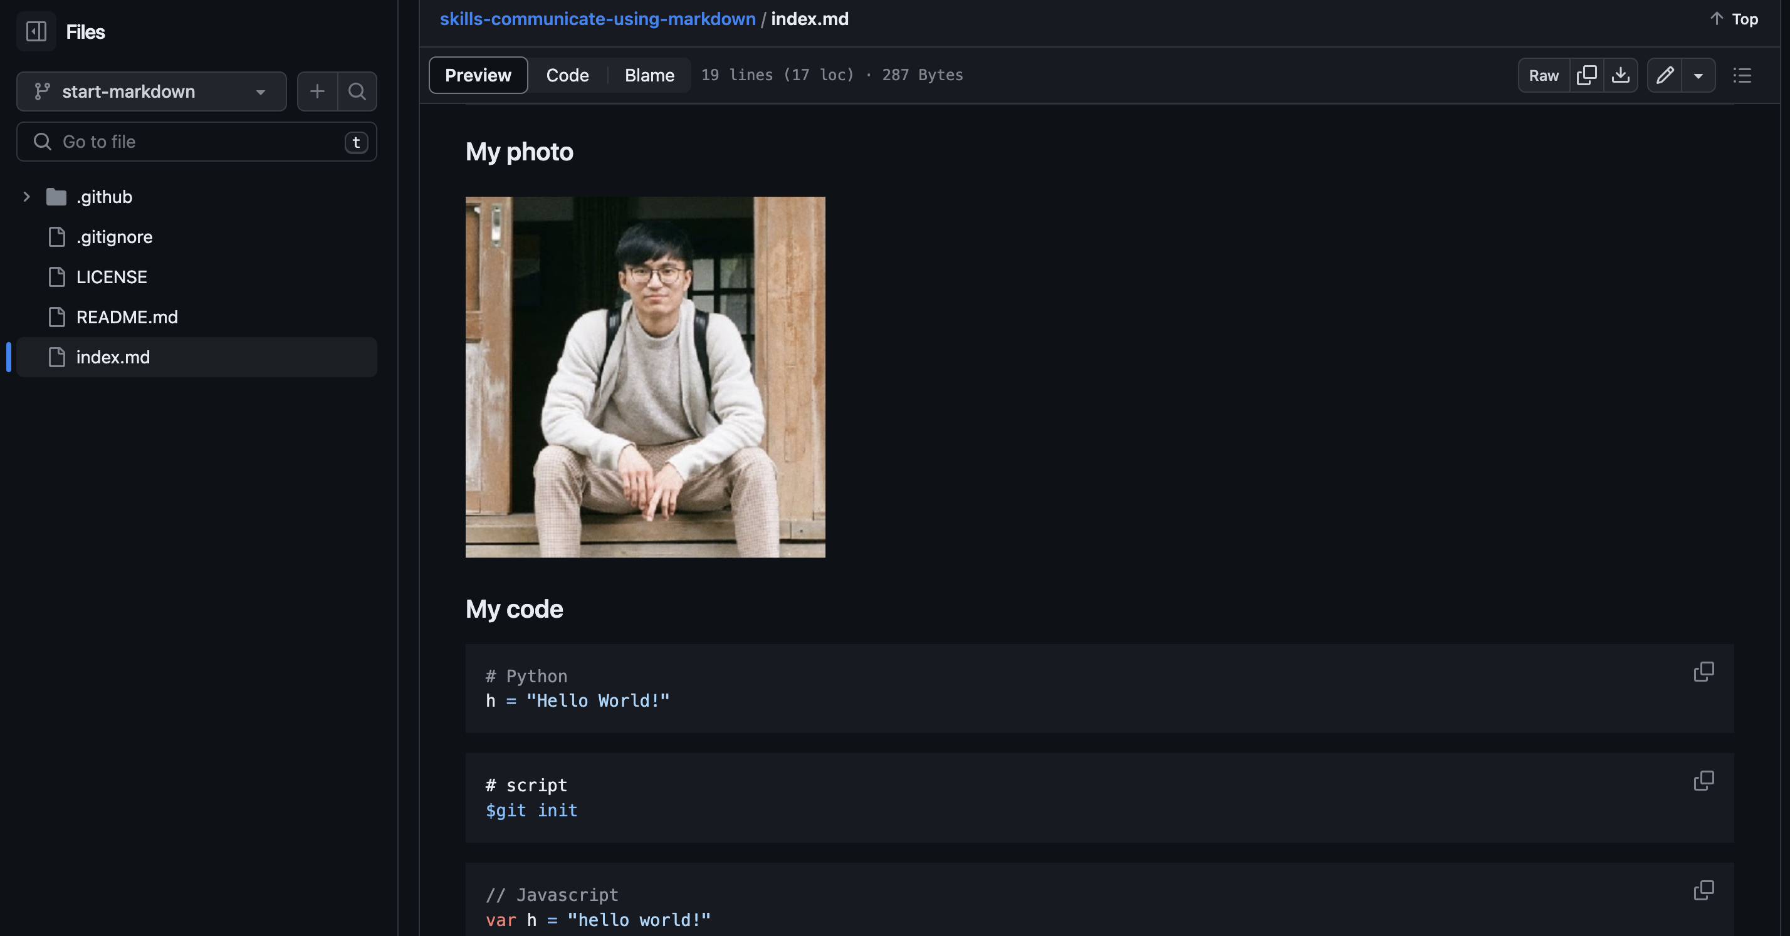

* + 1. **Add a task list**

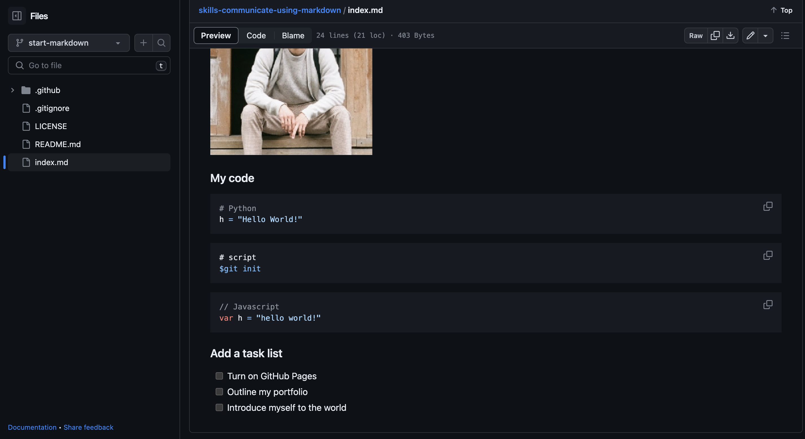

* + 1. **Merge Pull Request**

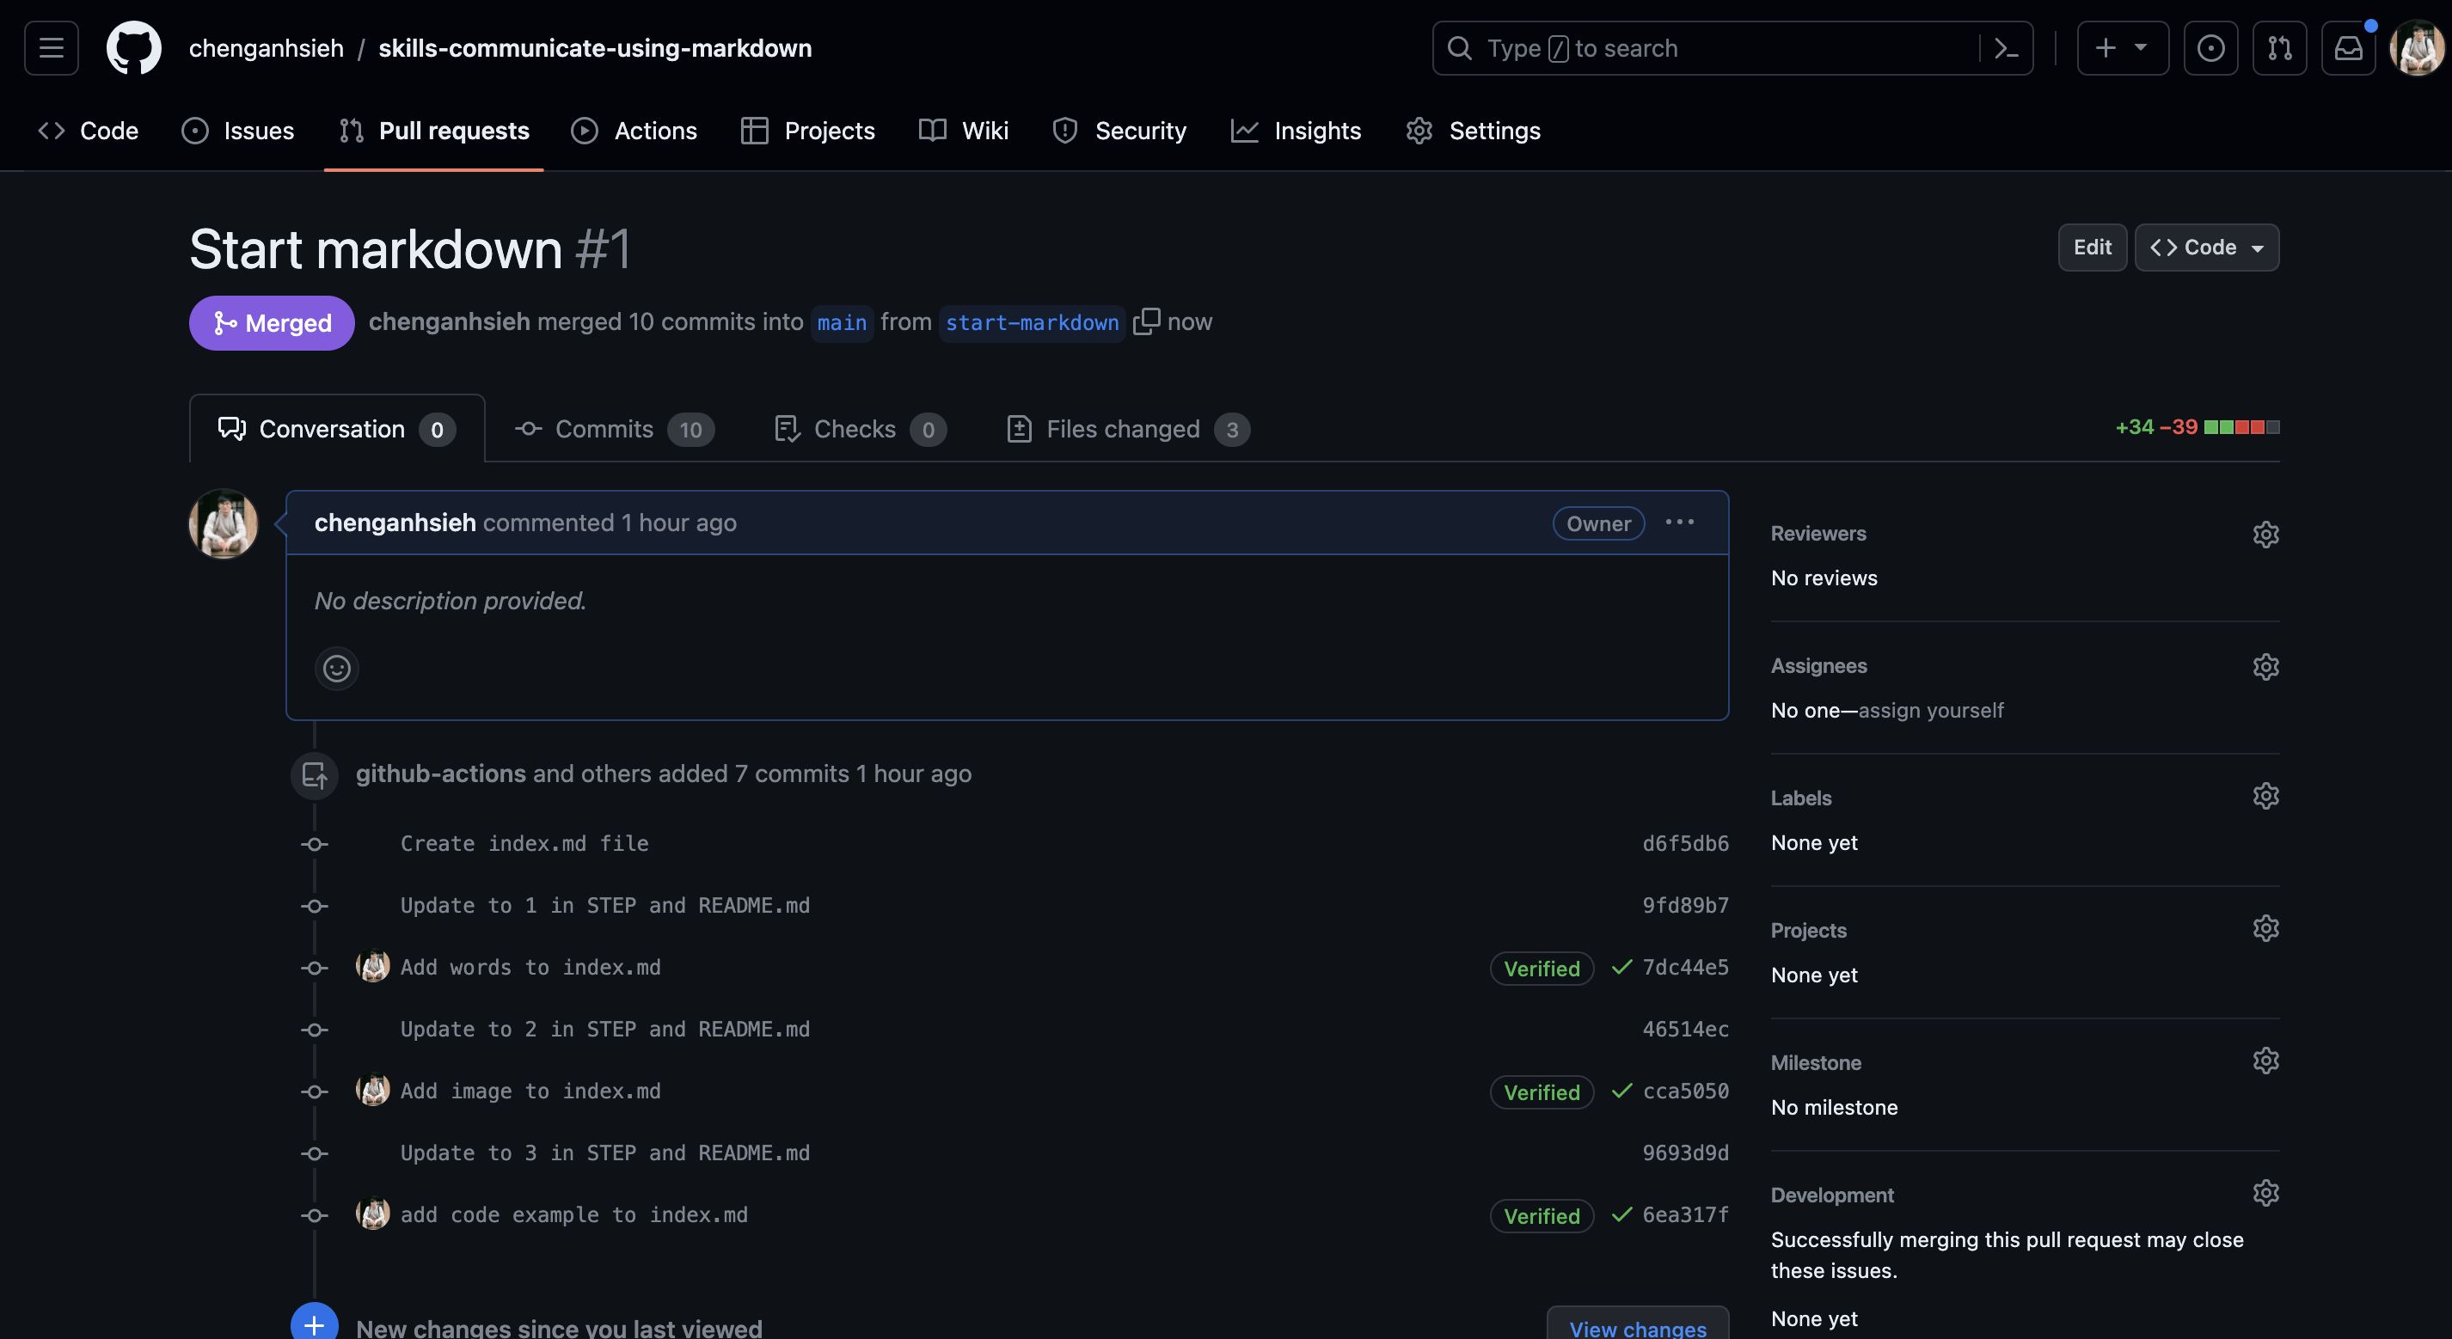

1. **Test-Toolchains Repository**
2. A screenshot of your GitHub repository history

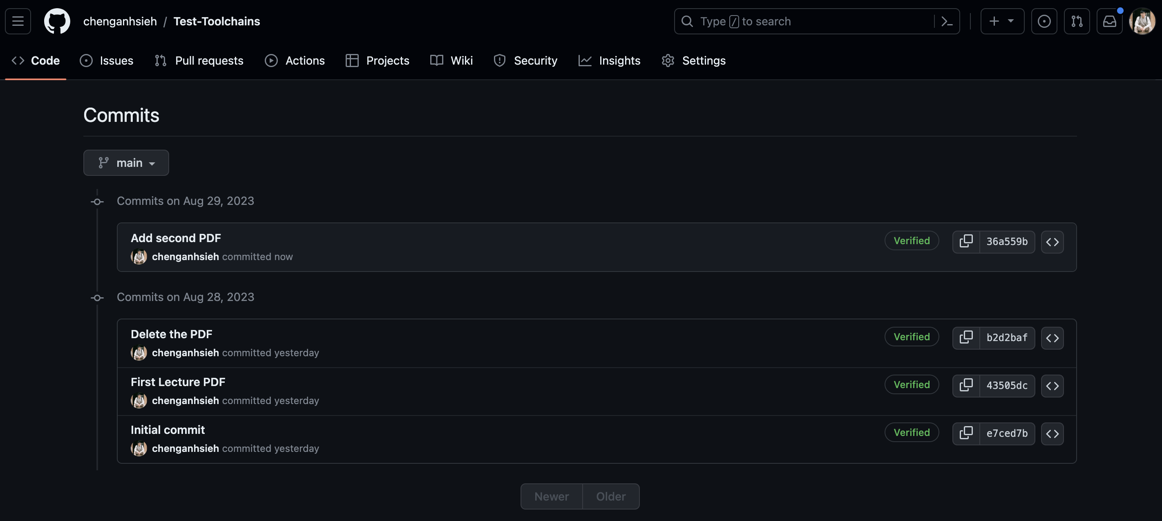

1. A screenshot of current view of your repository

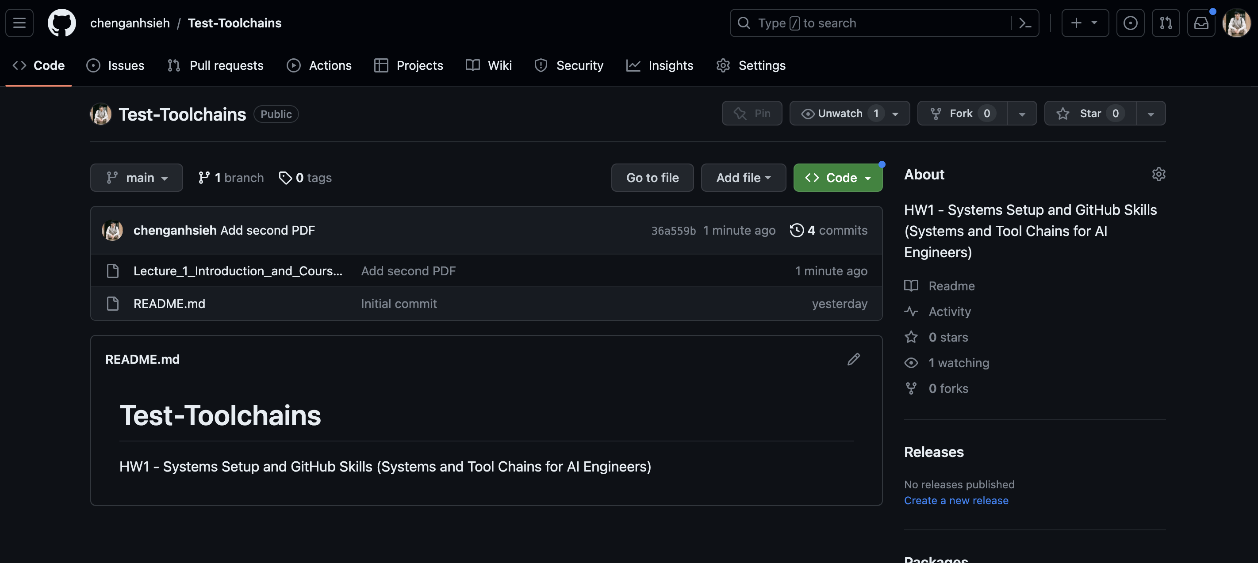

1. **URL:** [**https://github.com/chenganhsieh/Test-Toolchains**](https://github.com/chenganhsieh/Test-Toolchains)